Project 12

Methods and properties
Within Visual Basic there are a number of controls, each control has its own set of properties and methods that are used to set the appearance and behaviour of the control. Some controls have different sets of properties and methods. Also some controls have different set of events that can be programmed. The tables that follow compare three controls. They show how controls differ in the property sets, methods and events.

Properties
There are many possible sets of properties that can apply to objects. The list in the table of properties is some of the more common properties. It should be noted that the list is not a comprehensive list.
Control | Text Box | Timer | Shape
Text | Has | Does not have | Does not have
Interval | Does not have | Has | Does not have
Left | Has | Has | Has
Top | Has | Has | Has
Width | Has | Does not have | Has
Height | Has | Does not have | Has
Enable | Has | Has | Does not have
BorderStyle | Has | Does not have | Has
BorderWidth | Does not have | Does not have | Has
FillColor | Does not have | Does not have | Has
Forecolor | Has | Does not have | Has
Shape | Does not have | Does not have | Has
Visible | Has | Does not have | Has
Others | Has many others | Has a few more | Has many others
The properties of an object are similar in nature to variables in that they can be used within the let statement in a similar manner to variables. That is they can be set with the syntax item = value, or read with the syntax variable = item. Also object properties can be passed as parameters to functions and sub procedures.

Methods
Control | Text Box | Timer | Shape
Move | Has | Does not have | Has
Refresh | Has | Does not have | Has
Set Focus | Has | Does not have | Does not have
Z Order | Has | Does not have | Has
Others | Has others | Has no methods | No more
The way in which methods are used is similar to functions or sub procedures. There is a list of methods that are available for control the help for the control. Look at the help for textboxes and shapes. They can take parameters and undertake a set of actions on the object. The methods have a green icon in the auto completion list after the dot. Like functions and procedures they can be called using the syntax “call object dot method”. In this case a set of brackets are required around any parameters. The alternative manner in which the methods can be accessed is without the call and then the brackets around the parameters must be omitted. There is an example in the code for the move method with and without the call statement.
The meanings of some of the more common methods are list in the table that follows
Method name | Comments
Move | Positions the control in one operation setting left, top, width and height. The main advantage is the single redraw that will occur with a move rather than the redraw after every size change.
Refresh | Cause a complete repaint of the control.
Print | Prints on to the object see example in project 10
Setfocus | Sets the keyboard focus to that control
Show | Show only applies to forms and causes them to be displayed.
Hide | Hide only applies to forms and causes them to be hidden.
Zorder | Alters the order in which the objects are displayed.

Events
Control | Text Box | Timer | Shape
Timer | Does not have | Timer only event for Timer | No events for shapes
Change | Has
Click | Has
Double Click | Has
Key Press | Has
Others | Many | No others | None

So to summarise timers have a limited set of properties, no methods and one event. Shapes have many properties, some methods and no events. For text boxes there are many properties, many methods and many events. The sets of properties, methods and events for other object will be depend on the object. It is often a case of looking in the help to find the list of properties and methods that are available. Learning what every property does and how to use all the method is an almost impossible task. The more useful properties and methods will get used frequently and therefore by repetition you will quickly become familiar with them.

Example Code
The example code that follows includes demonstrations of how some of the events and methods can be used to good effect. At this stage I have assumed the uses of properties are understood, at least in the way in which they are changed and read.
The demonstration program consists of three text boxes and a command button. The screen shot that follows shows the layout once the form is repositioned by the resize event code. The only code in the program is the ‘unload’ statement for closing the program and the resize code to position the text boxes and command when the form is changed in size.
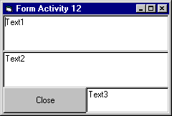
Enter the code that follows and then try minimising, maximising the form and altering the size, dragging the corner to stretch the form. Notice the positions are not altered after the height is reduced below a particular value based on the design height of the command button. Try altering the design height of the command button and see the effects. Also notice that when the width reaches a limit there is no change of the width. We will look at the way in which this can be achieved for the height in a later part of the project.
Option Explicit
Private Sub CommandClose_Click()
Unload Me
End Sub
Private Sub Form_Resize()
Dim TopPos As Single
Dim T3Width As Single
Dim T12Width As Single
Dim T12Height As Single
'Position Command buton up from bottom of the form
TopPos = ScaleHeight - CommandClose.Height
'Split the width between the command and Text3
T3Width = ScaleWidth / 2
‘width of Text 1 and 2 scale width of form
T12Width = ScaleWidth
'Split remaining height between text1 and text2
T12Height = TopPos / 2
Debug.Print T12Width, T12Height, T3Width, ScaleWidth, TopPos
'test to ensure not trying to draw too small a textbox
If T12Height > CommandClose.Height Then
'methods with call
Call CommandClose.Move(0, TopPos, T3Width)
Call Text3.Move(T3Width, TopPos, T3Width)
'methods without call
Text1.Move 0, 0, T12Width, T12Height
Text2.Move 0, T12Height, T12Width, T12Height
End If
End Sub
Once the program is running and the size is altered the form will remain laid out with the command button and text 3 spilt at the bottom and text 1 and 2 in the remaining height of the form
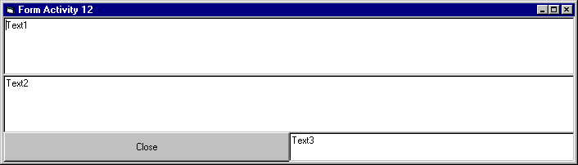

Form with border code
The code that follows is an amended version of the previous code. In order to maintain the previous code the present code was saved as Form12border and added this form as an existing form to the project. Then the new form was changed as the start up object in the project properties.
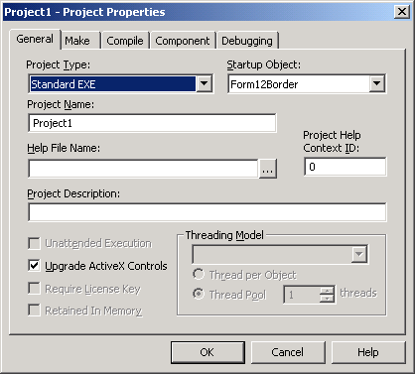
The following features have been added to the program.
- The resize event uses a border when calculating the positions of the text boxes and command button.
- The text3 value is used to set the border. When the text in the text box changes the value is read into the global variable of border.
- The key press events have been coded to filter the characters that are valid for the text boxes.
- The double click event for text1 has code to show the original form.
Option Explicit
Dim border As Single
Private Sub CommandClose_Click()
End
End Sub
Private Sub Form_Load()
Text3.Text = 50
End Sub
Private Sub Form_Resize()
Dim TopPos As Single
Dim T3W As Single ‘ Text3 and command Width
Dim T12W As Single ‘ text1 and 2 width
Dim T12H As Single ‘text1 and 2 height
'Position Command buton up from bottom of the form
TopPos = ScaleHeight - CommandClose.Height - border
'Allow for border to left and right of command and Right ot Text3
T3W = (ScaleWidth - 3 * border) / 2
'Allow for border to left and right of text1
T12W = ScaleWidth - (2 * border)
'Allow for Border above and below text1 and below text2
T12H = (TopPos - 3 * border) / 2
Debug.Print T12W, T12H, T3W, ScaleWidth, TopPos, border
'test to ensure not trying to draw to small a textbox
If TopPos > (4 * border) Then
Call CommandClose.Move(border, TopPos, T3W)
Call Text3.Move(2 * border + T3W, TopPos, T3W)
Text1.Move border, border, T12W, T12H
Text2.Move border, T12H + 2 * border, T12W, T12H
End If
End Sub
Private Sub Text1_Change()
'Try Adding this code but causes problems
'Text2.Text = Val(Text3.Text) + Val(Text1.Text)
End Sub
Private Sub Text1_DblClick()
Form12.Show
End Sub
Private Sub Text1_KeyPress(KeyAscii As Integer)
'If the character is in the list of digits or backspace allow
'Test is zero if no position is found in the list
If InStr("-+0123456789." & Chr(8), Chr(KeyAscii)) = 0 Then
KeyAscii = 0
Beep
End If
End Sub
Private Sub Text2_Change()
Text1.Text = Val(Text3.Text) - Val(Text2.Text)
End Sub
Private Sub Text2_KeyPress(KeyAscii As Integer)
If KeyAscii = 13 Then Text1.SetFocus
'If the character is in the list of digits or backspace allow
'Test is zero if no position is found in the list
If InStr("-+0123456789." & Chr(8), Chr(KeyAscii)) = 0 Then
KeyAscii = 0
Beep
End If
End Sub
Private Sub Text3_Change()
border = Val(Text3.Text)
If border > 250 Then Text3.Text = 250
Call Form_Resize
End Sub
Private Sub Text3_KeyPress(KeyAscii As Integer)
'if enter move focus to text2
If KeyAscii = 13 Then Text2.SetFocus
'If the character is in the list of digits or backspace allow
'Test is zero if no position is found in the list
If InStr("0123456789." & Chr(8), Chr(KeyAscii)) = 0 Then
KeyAscii = 0
Beep
End If
End Sub

Code to limit the height
The bold text in the code below has been added to the no border version form. Amend the program and test its action.
Private Sub Form_Resize()
Dim TopPos As Single
Dim T3Width As Single
Dim T12Width As Single
Dim T12Height As Single
'Position Command buton up from bottom of the form
TopPos = ScaleHeight - CommandClose.Height
'Split the width between the command and Text3
T3Width = ScaleWidth / 2
'width of Text 1 and 2 scale width of form
T12Width = ScaleWidth
'Split remaining height between text1 and text2
T12Height = TopPos / 2
Debug.Print T12Width, T12Height, T3Width, ScaleWidth, TopPos
'test to ensure not trying to draw too small a textbox
If T12Height > CommandClose.Height Then
'methods with call
Call CommandClose.Move(0, TopPos, T3Width)
Call Text3.Move(T3Width, TopPos, T3Width)
'methods without call
Text1.Move 0, 0, T12Width, T12Height
Text2.Move 0, T12Height, T12Width, T12Height
Else
If Me.WindowState = 0 Then
Dim barHeight As Single
'height - scale height is the title bar height
barHeight = (Height - ScaleHeight)
Height = barHeight + 3 * CommandClose.Height
End If
End If
End Sub

